EX NO.7 KEERTHIKA K DATE:23.09.2025 241901046

ANONYMOUS FTP

AIM:
Check whether an FTP server allows anonymous login and, if successful, print the server
welcome message and directory listing.
Algorithm:
1. Accept the target hostname.
2. Create an ftplib.FTP connection to the host.
3. Attempt to login using the credentials user=&#39;anonymous&#39; and passwd=&#39;anonymous&#39;.
4. If login response indicates success (230 Anonymous access granted):
o Print success message, the server welcome text, and call ftp.dir() to list the
directory.

5. If any exception occurs or login fails, print the error and a failure message.
6. Close/exit when done (implicit on program end).

CODE:
import ftplib
def anonymousLogin(hostname):
try:
ftp = ftplib.FTP(hostname)
response = ftp.login(&#39;anonymous&#39;, &#39;anonymous&#39;)
print(response)
if &quot;230 Anonymous access granted&quot; in response:
print(&#39;\n[*] &#39; + str(hostname) +&#39; FTP Anonymous Login Succeeded.&#39;)
print(ftp.getwelcome())
ftp.dir()
except Exception as e:
print(str(e))
print(&#39;\n[-] &#39; + str(hostname) +&#39; FTP Anonymous Login Failed.&#39;)
hostname = &#39;ftp.be.debian.org&#39;
anonymousLogin(hostname)

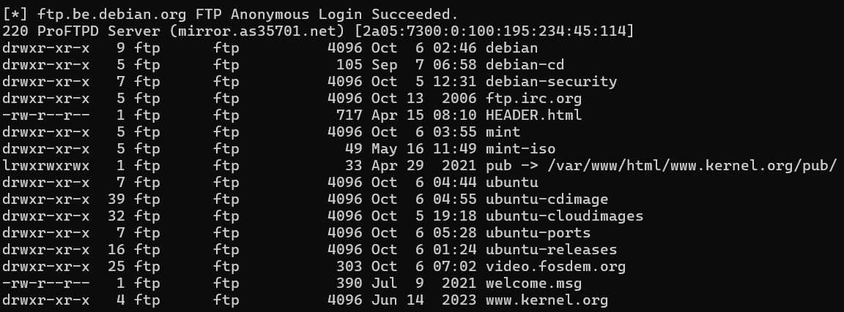

RESULT:
On success: prints the FTP server response (e.g. 230 Anonymous access granted), a success
notice like
[*] ftp.be.debian.org FTP Anonymous Login Succeeded., the welcome/banner, and the
server directory listing.
• On failure (or exception): prints the exception text and a failure notice like
[-] ftp.be.debian.org FTP Anonymous Login Failed.

